Multiple-choice section

|  |  |  |  |  |  |  |  |  |
| --- | --- | --- | --- | --- | --- | --- | --- | --- |
| Question | 1 | 2 | 3 | 4 | 5 | 6 | 7 | 8 |
| Answer | C | C | D | D | D | A | B | D |

Question 1 [5.1]

C





  12 =   12

4(4*x* +6) = 3(12 − 4*x*)

16*x* +24 = 36 − 12*x*

28*x* = 12

*x* = 

Question 2 [5.2]

C

**

Question 3 [5.3]

D

Let (*x*1, *y*1) = (-, -) and (*x*2, *y*2) = (-, -)

Write the midpoint formula, substitute in the relevant values, and evaluate.



Question 4 [5.4]

D

*a* increases by 2 and *b* decreases by 6, so the multiplying factor is -3. *b* = 5 when *a* = 0, so 5 will be the constant that is added after *a* is multiplied.

*b* = -3*a* + 5

Check by substituting a pair of values from the table.

When *a* = 2, *b* = -3 × 2 + 5 = -1

Question 5 [5.5]

D

Sketching *a*, *b* and the hypotenuse:

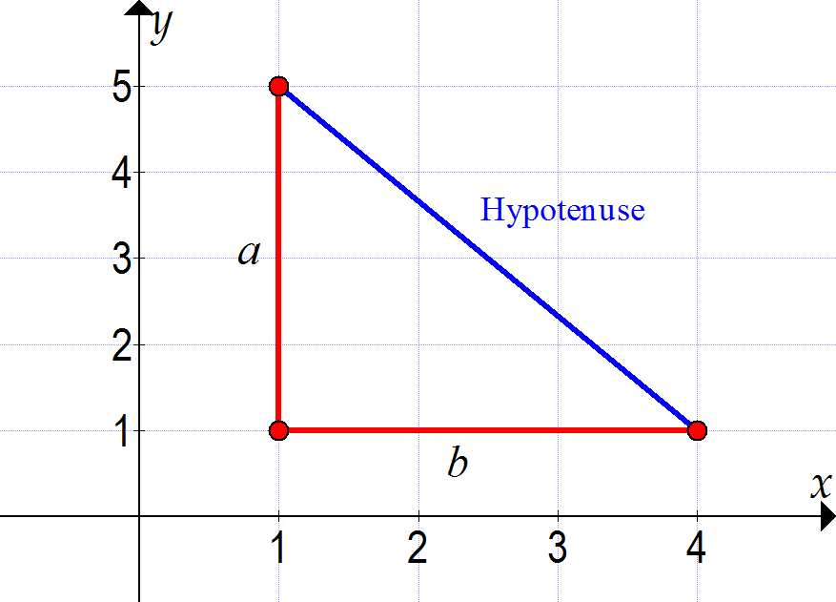

The rule for finding the gradient of the hypotenuse is:

*m* =  = 

The hypotenuse has coordinate points (4, 1) and (1, 5). Substitute values into the rule and evaluate.

*x*1 = 4, *x*2 = 1, *y*1 = 1, *y*2 = 5



Question 6 [5.6]

A

*ax* + *by* + *c* = 0

*by* = -*ax* − *c*

*y* = -*x* −

The coefficient of *x* is the gradient: *m* = -**

The product of the gradients of perpendicular lines is -1: *m*1 × *m*2 = -1

Substitute *m*1 = -**:

-**× *m*2 = -1

-**× -× *m*2 = -1 × -

*m*2 = -1 × -= .

The perpendicular line has a gradient of .

Question 7 [5.7]

B



2(*x* + 3) = 3(*y* + 4)

2*x* + 6 = 3*y* + 12

2*x* − 3*y* = 6

Note that the alternatives given are coordinates of the *x*- and *y*-intercepts.

Calculate the *x*-intercept by substituting *y* = 0 and solving the equation.

2*x* − 3*y* = 6

When *y* = 0

2*x* = 6

*x* = 3

∴ *x*-intercept = (3, 0)

Calculate the *y*-intercept by substituting *x* = 0 and solving the equation.

2*x* − 3*y* = 6

When *x* = 0

-3*y* = 6

*y* = -2

∴ *y*-intercept = (0, -2)

Question 8 [5.8]

D

*P* =  +  + +

*P* = + + + + 12

*P* = + 12

*P* = + 12

The perimeter is 19 units.

19 = + 12

7 =

7 = 

6 = *b*

Substitute *b* = 6 into the line segments:

Vertical:  =  = 6

Horizontal: =  = 3

The rectangle has a length of 6 units and a width of 3 units.

Since one vertical side lies on the line *x* = 2, the other side will be 3 units to the right, or the width of the rectangle, to the right of this line, or *x* = 5.

Multiple-choice total marks: 8

Short answer section

Question 9 4 marks [5.1]

‘One-quarter of the result of a number *x* subtracted from 20’ can be written as: 

‘one-third of the sum of *x* and 8’ can be written as: 

Since these statement are equal:

 = 

Solve for *x*:

= 

= 

3(20 − *x*) = 4(*x* + 8)

60 − 3*x* = 4*x* + 32

28 = 7*x*

4 = *x*

Question 10 6 marks [5.2]

(a) 2*x* + 15 + 5*x* + 60 = 180

7*x* + 75 = 180

7*x* = 105

*x* = 15

The unknown angles are: 2*x* + 15 = 2 × 15 + 15 = 45°

and 5*x* = 5 × 15 = 75°

(b) *P* = 2(*l* + *w*)

*l* = 2*w* – 5

2(2*w* − 5 + *w*) = 32

3*w* − 5 = 16

3*w* = 21

*W* = 7

The width is 7 cm and the length is 2 × 7 − 5 = 14 − 5 = 9 cm.

It is a 7 × 9 cm rectangle.

Question 11 5 marks [5.3]

(a) *AC*: 

*BC*: 

*AB*: 

(b) This is a 3, 4, 5 triangle so it is a right-angled scalene triangle.

(c) midpoint = 

Question 12 4 marks [5.4]

(a)

|  |  |  |  |  |
| --- | --- | --- | --- | --- |
| P | 0 | 3 | 6 | 9 |
| T | -0.75 | 0.75 | 2.25 | 3.75 |

**(b)**

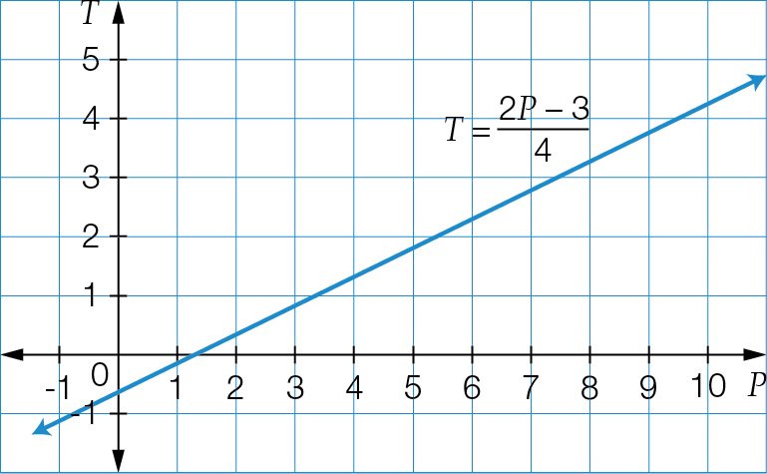

Question 13 6 marks [5.5]

(a)

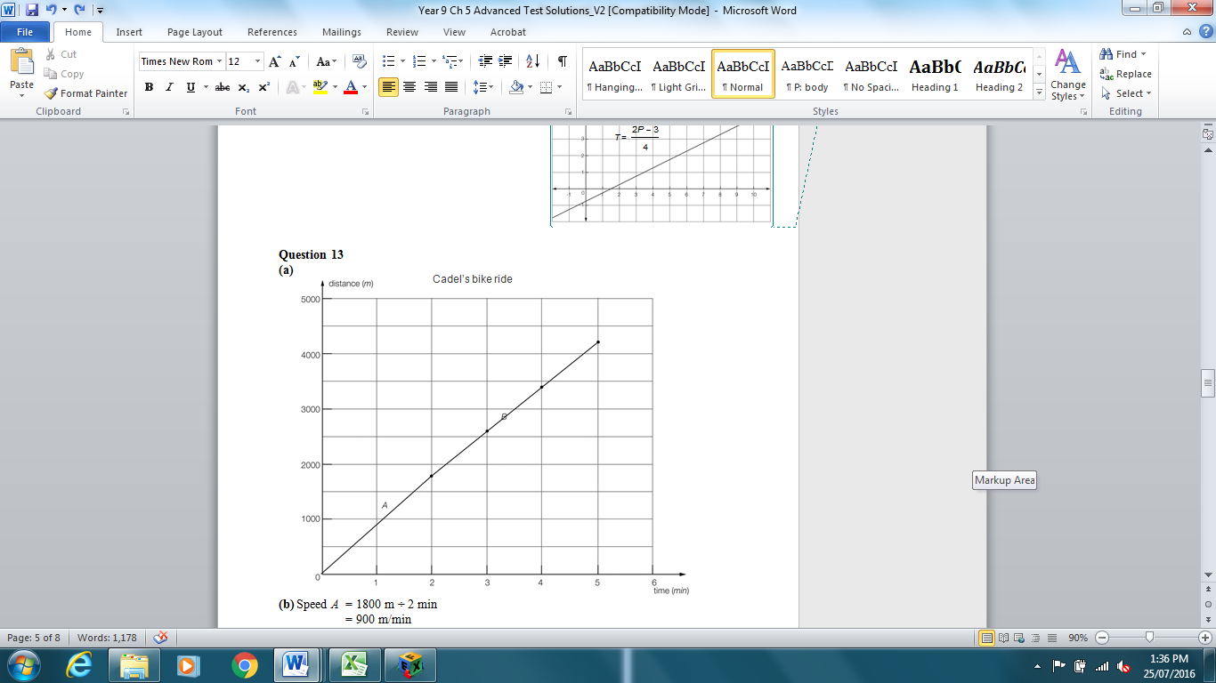

(b) speed *A* = 1800 m ÷ 2 min

= 900 m/min

speed *B* = 2400 m ÷ 3 min = 800 m/min

(c) gradient *A* = = 900

gradient *B* = = 800

(d) (i) Speed is the gradient of the distance–time graph.

(ii) Cadel is travelling faster in part *A*. This part has a steeper gradient on the graph.

(e) 5 minutes at 900 m/min: 900 × 5 = 4500 m = 4.5 km

Cadel travels 1.8 km + 2.4 km = 4.2 km

He would travel an extra 0.3 km or 300 m.

Question 14 2 marks [5.6]

5*x −*4*y* = 20

Rearrange into gradient–intercept form:

-4*y* = 20 − 5*x*

*y* = *x* – 5

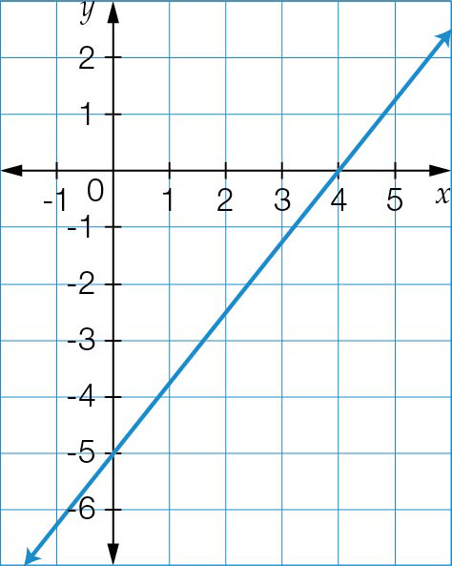

*m* = , *b* = -5

Question 15 2 marks [5.7]

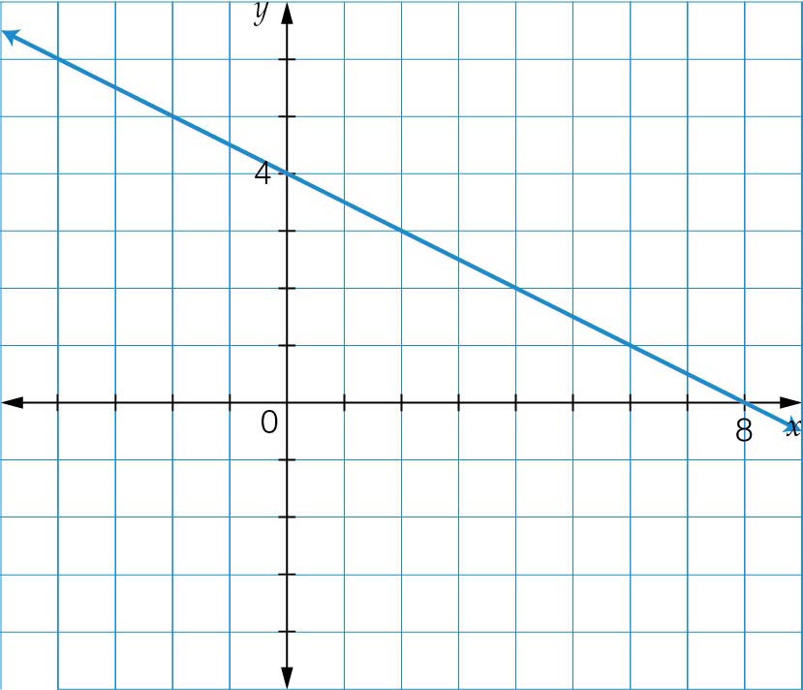

= 4

When *x* = 0,



*y* = 4

*y*-intercept = (0, 4)

When *y* = 0,





*x* = 8

*x*-intercept = (8, 0)

Question 16 4 marks [5.8]

(a) *y* = 2

(b) *y* = -2

(c) *y* = 2*x* + 6

(d) *y* = -5*x* − 2

Short answer total marks: 33

Extended answer section

Question 17 10 marks [5.3]

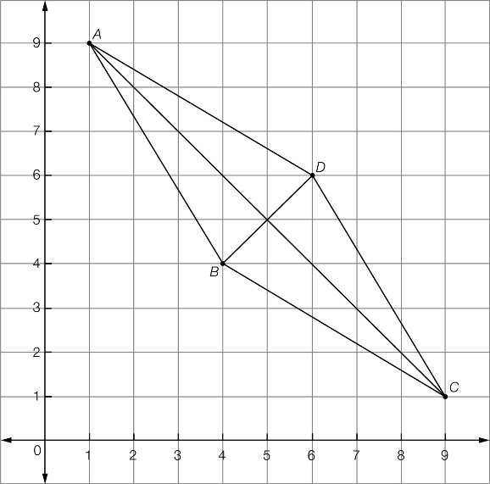

(a) *AB*: 

*AD*: 

*CD*: 

*BC*: 

(b) *AC*: 

*BD*: 

(c) All sides are the same length and the opposite sides are parallel. Therefore, the shape is a rhombus.

(d) midpoint *AC*:  = (5, 5)

midpoint *BD*:  = (5, 5)

**(e)** The midpoints of the diagonals coincide.

Question 18 10 marks [5.4]

(a)

|  |  |  |  |  |  |  |  |  |  |
| --- | --- | --- | --- | --- | --- | --- | --- | --- | --- |
| Number of books/reader | 0 | 1 | 2 | 3 | 4 | 5 | 6 | 7 | 8 |
| Axel | 0 | 1.5 | 3 | 4.5 | 6 | 7.5 | 9 | 10.5 | 12 |
| Brandon | 3 | 4 | 5 | 6 | 7 | 8 | 9 | 10 | 11 |
| Clarissa | 10 | 10 | 10 | 10 | 10 | 10 | 10 | 10 | 10 |

(b)

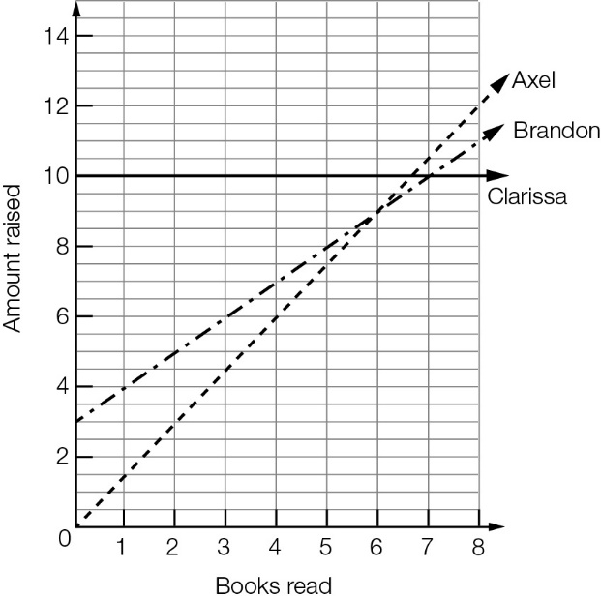

(c) No, they never collect the same amount, as there is no point at which all three lines intersect.

(d) (i) 7 or more books

(ii) never

(iii) 6 or fewer books

Question 19 12 marks [5.6, 5.7, 5.8]

(a)

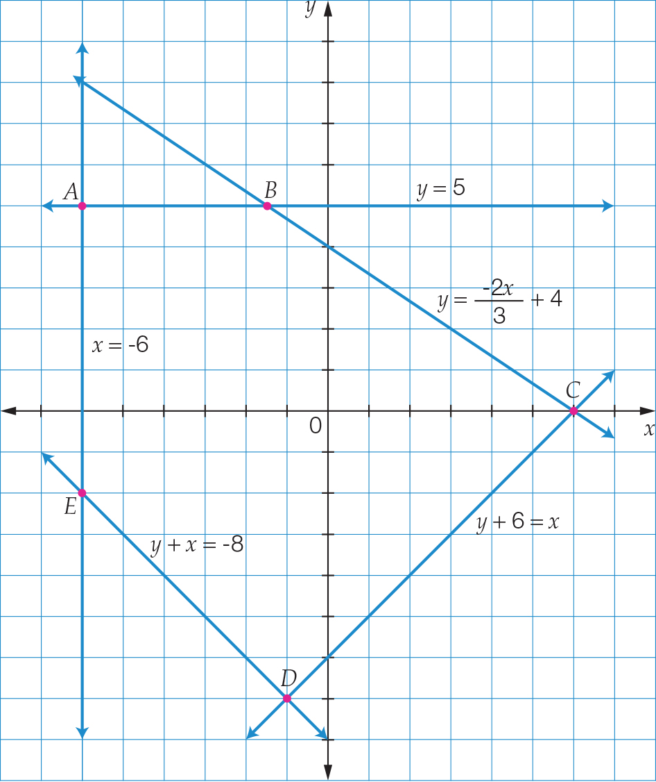

**(b)** *A*(-6, 5); *B*(-1.5, 5); *C*(6, 0); *D*(-1, -7); *E*(-6, -2)

**(c)** It passes through (-6, 5) and (0, 0), so it has gradient of : *y* = 

**(d)** It passes through (-1, -7) and (0, 0), so it has gradient of 7: *y* = 7*x*

Extended answer total marks: 32

TOTAL test marks: 73